Date : 17/10/2022

Submission Date : 09/11/2022

Before 2.00 p.m.

**Assignment 1**

1. Create ordered list in html which contains five items. The number should be in gujarati.
2. Create under order list in html which contains five items. The bullets should be image.
3. Create a html webpage which demonstrates following table

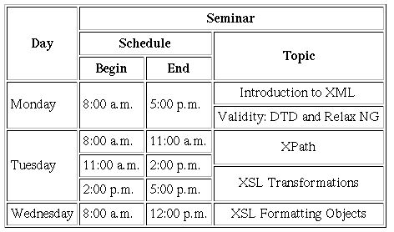

1. Create a html webpage which show your current semester timetable. Apply different shading to each column from first column the lighter shade and the last column the darkest shade of the same color. Also display DDU logo on the upper left corner of the table.